**Automator Manual**

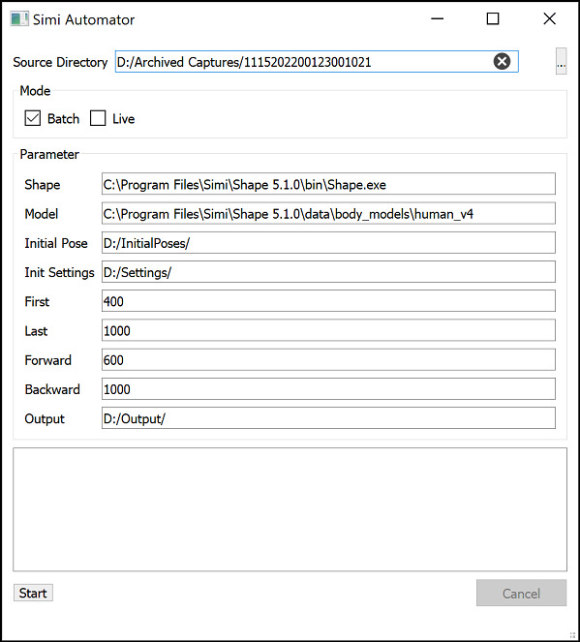**Setup –** Each section of the Automator requires a specific input. Use the descriptions below to properly fill in each section.

**Source Directory –** Input the file path for the folder which contains all the exercise folders you would like to track. You can use the browse button (…) next to the line to search for the folder then select it.

**Mode –** Batch is the most likely used mode for the Automator. This is for use after all the movements have been captured and you are “batch processing” all the files after the fact. Live mode can be used under certain conditions to track alongside capture as the files come in. Unless directed by S3D or Simi you should not use live mode.

**Shape –** Input the file path for the Shape version you will use to track. This should not change unless instructed to do so by S3D or Simi. They will likely change this for you.

**Model –** Input the file path for the Shape Model version you will use to track. This should not change unless instructed to do so by S3D or Simi. They will likely change this for you.

**Initial Pose –** Input the file path for a folder containing initial pose files. For instructions on how to create an initial pose for an exercise/athlete reference the, “Initial Poses and Tracking Settings Manual”.

**Init Settings –** Input the file path for a folder containing Init and Track settings. For instructions on how to create Init and Track settings reference the, “Initial Poses and Tracking Settings Manual”.

**First –** This is the value of the first frame you would like to start searching for the initial pose. This may vary per exercise. It can be as low as 0, and the range between the First and Last Init search frame can span the entire exercise length, but this will make tracking take longer, so it is best to try and get a more accurate estimate of around when the initial pose will occur.

**Last –** This is the value of the last frame you would like to search for the initial pose. This may vary per exercise. It can be as high as the last frame of the exercise, and the range between the First and Last Init search frame can span the entire exercise length, but this will make tracking take longer, so it is best to try and get a more accurate estimate of around when the initial pose will occur.

**Forward –** This is the number of frames you would like to track forwards from the initial pose frame. If you would like to be sure you track the entire exercise, make this value equal to the “First” value you input.

**Backward -** This is the number of frames you would like to track backwards from the initial pose frame. If you would like to be sure you track the entire exercise, make this value equal to the “Last” value you input.

**Output –** This is the file path where you would like to have your tracked files be saved to. By default this is set to D:/Output. You should keep this consistent so all your files are saved to the same spot. A folder with the name (in this case 1115202200123001021) will be created in the output folder with the same folder structure as the original except for now each exercise folder will contain a tracked .smp file and Shape settings and model information files (.shp and .shpdata).

**Other information**

1. In order for a movement file to be tracked corrrectly, the folder structure for that movement must be as follows:
   1. 1 .xml data file. This will contain information on the exercise and the subject.
   2. 1 .smp file. This file compiles all the videos and is what will be tracked in Shape.
   3. ****8 .avi video files. These contain the video information from each camera. The number of video files should be equal to the number of cameras you have (8 is standard). If there are less than 8 video files your settings will likely not match the videos accurately and lead to possibly inaccurate tracking.
2. ****Once you begin tracking, in the bottom lefthand corner of the Automator window you will see a “File Queue Size” number. This will indicate how many files are still waiting to be tracked before the Automator is finished. When you begin tracking this number should be equal to the number of exercises you have in the folder you are tracking.
3. As tracking progresses each new file that is being tracked will get a timestamp notification in the Automator window. This denotes when Shape opened in the background for this trial and began tracking. This can help you track progress of the tracking.

